**Linux Environment Variable**

**1. State the command for the following.**

a. view current environment variables

**Ans:** printenv or env is to view current environment variables.

b. display the PATH environment variable value

**Ans:** echo $PATH is to display the PATH environment variable.

c. update PATH to include the path to your home directory

**Ans:** export PATH=$HOME:$PATH

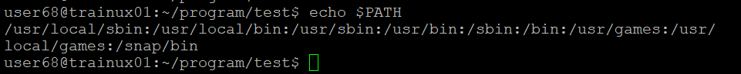

**2. How will you make the environment changes applicable to all users? Which script is to be modified?**

**Ans:** sudo nano /etc/profile

**3. I have installed an application named “myapp”. After installation, if I invoke the application, it fails with error as “Command myapp not found”. How will you fix this?**

**Ans:** add the location of application to the PATH